Bluetooth Speaker Build Summer 2020

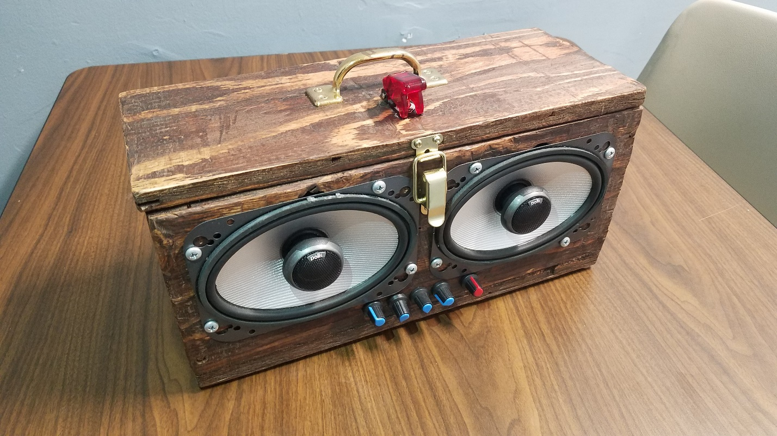

Figure 1: Exterior View of Front of Cabinet

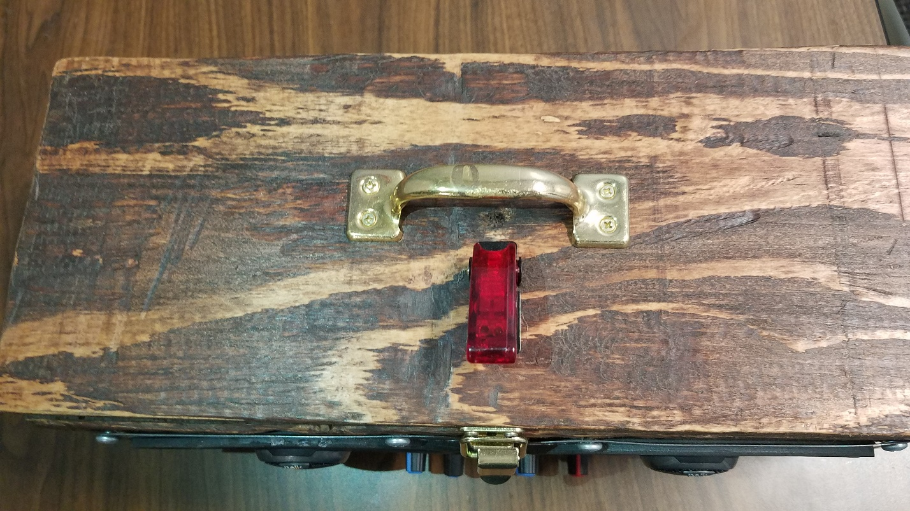

Figure 2: Exterior View of Top of Cabinet with Switch Off

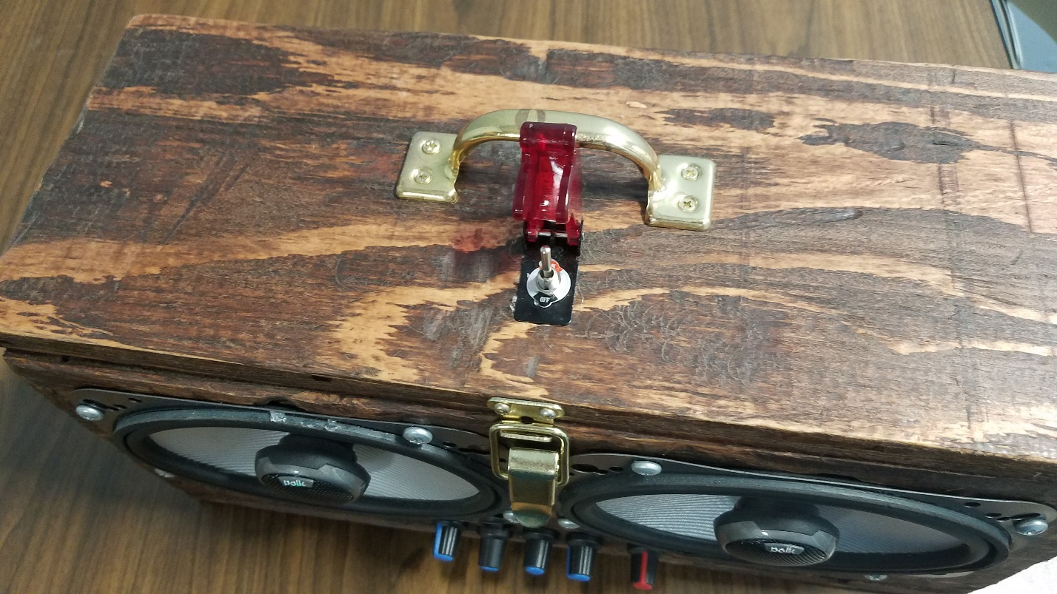

Figure 3: Exterior View of Top of Cabinet with Switch On

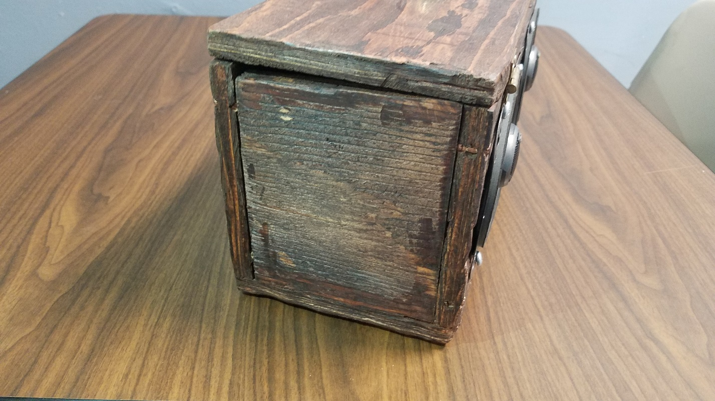

Figure 4: Exterior View of Left Side of Cabinet

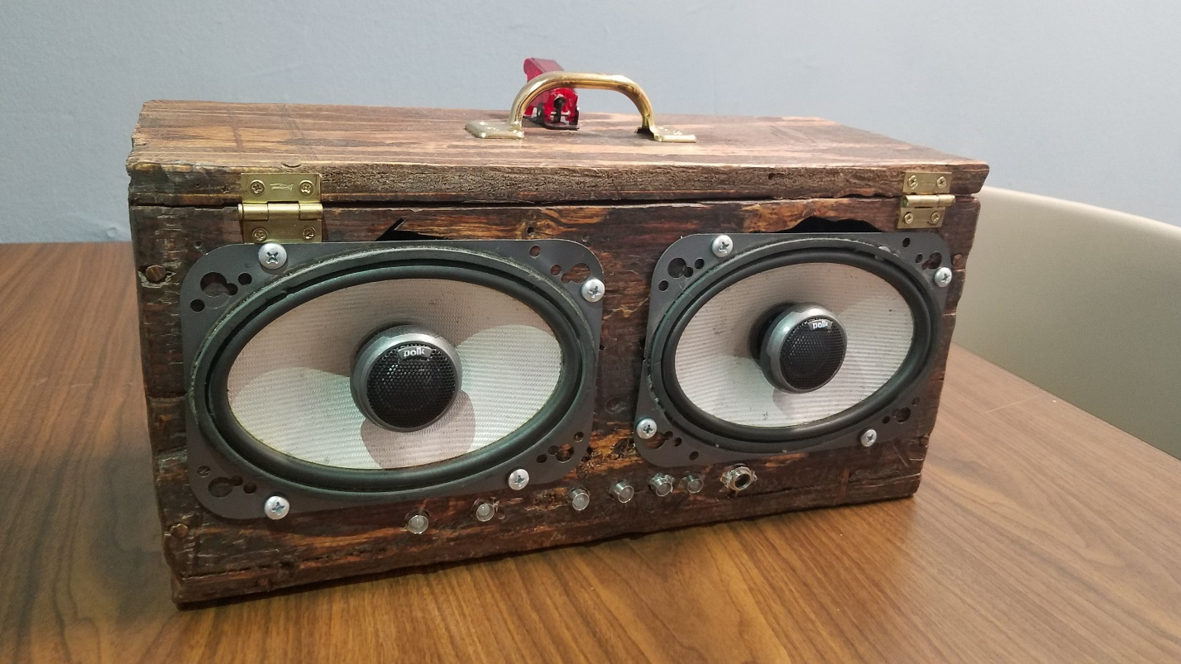

Figure 5: Exterior View of Rear Side of Cabinet

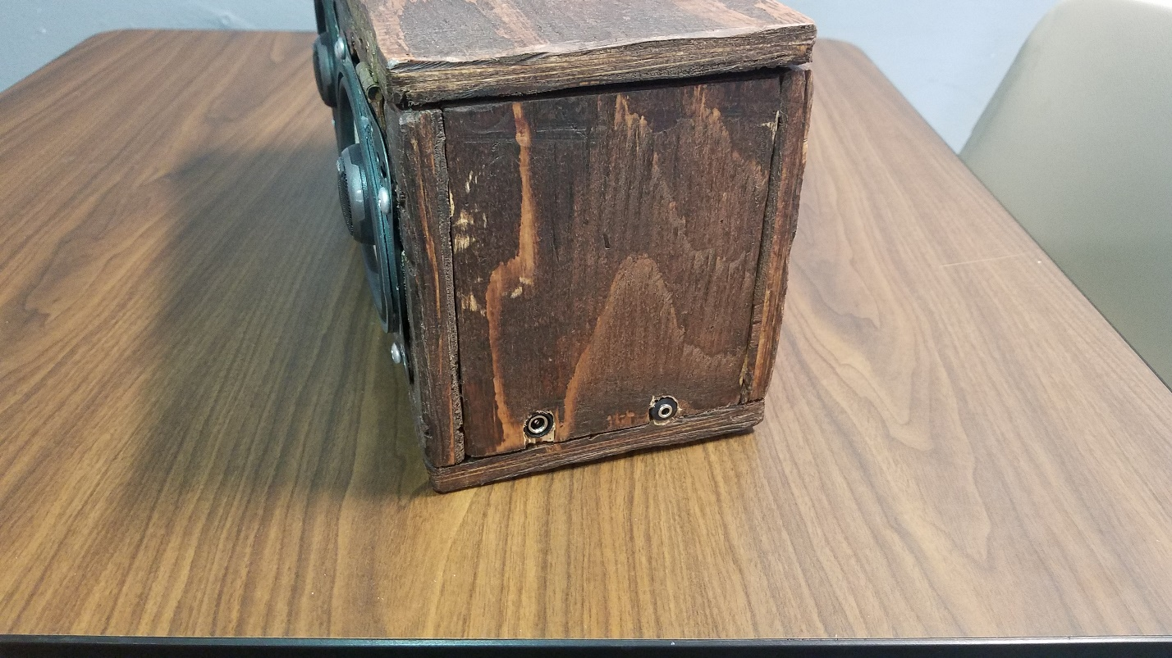

Figure 6: Exterior View of Right Side of Cabinet

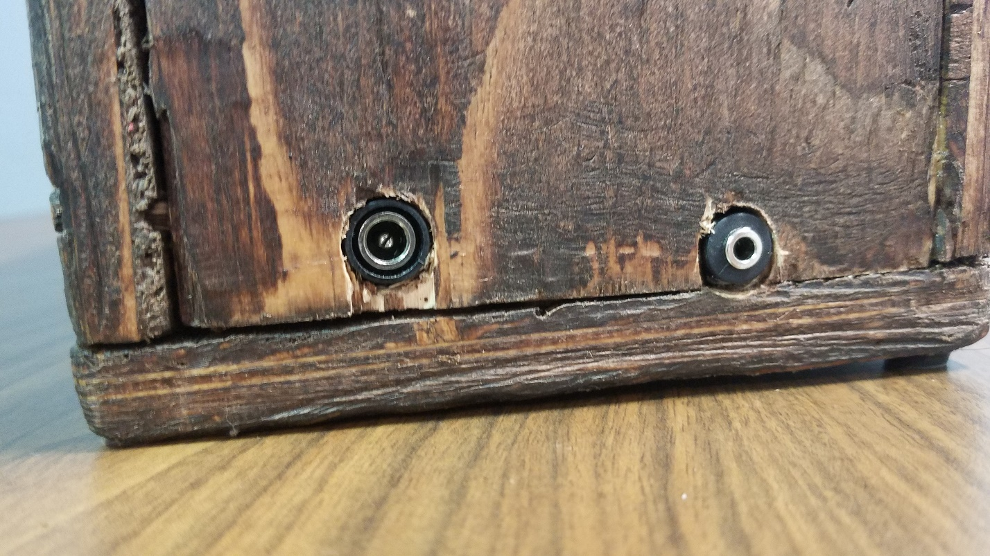

Figure 7: Exterior View of Right Side of Cabinet with focus on ports (12V DC, 3.5mm AUX In)

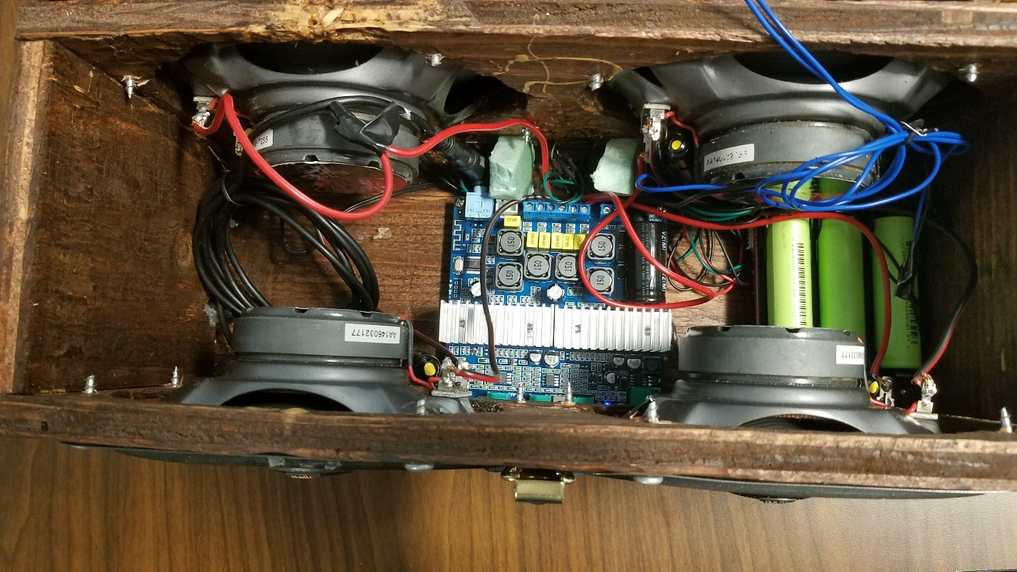

Figure 8: Interior View of Cabinet

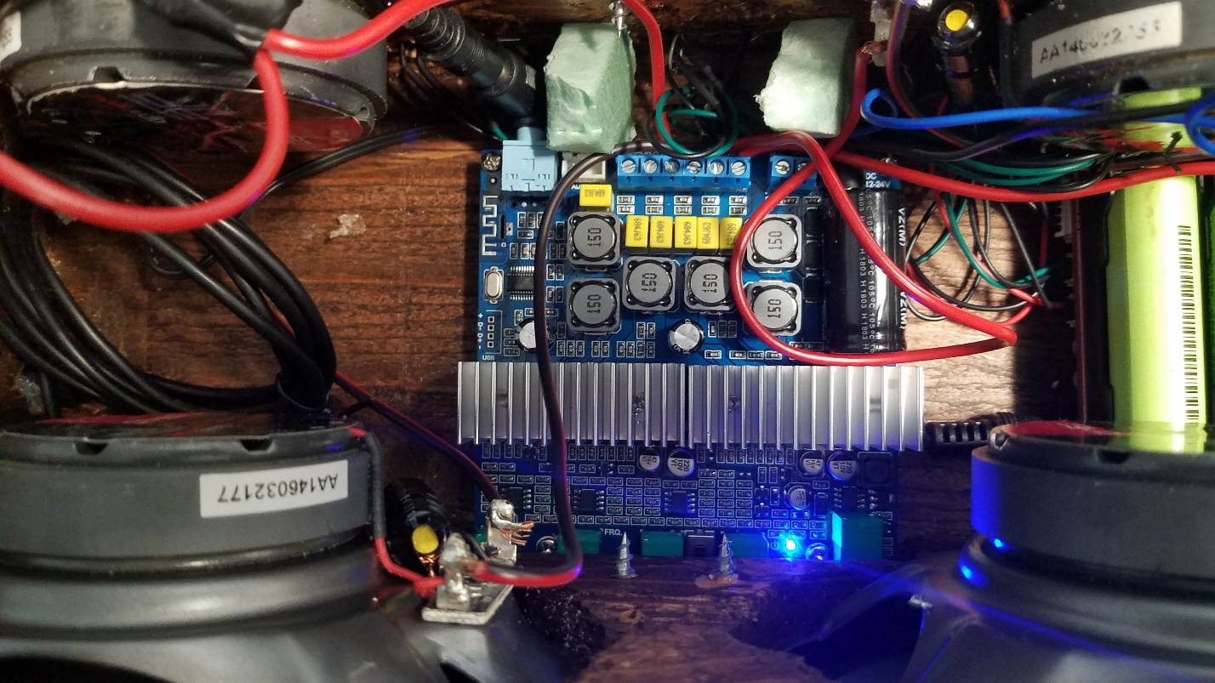

Figure 9: Internal View of Bluetooth Amp Board

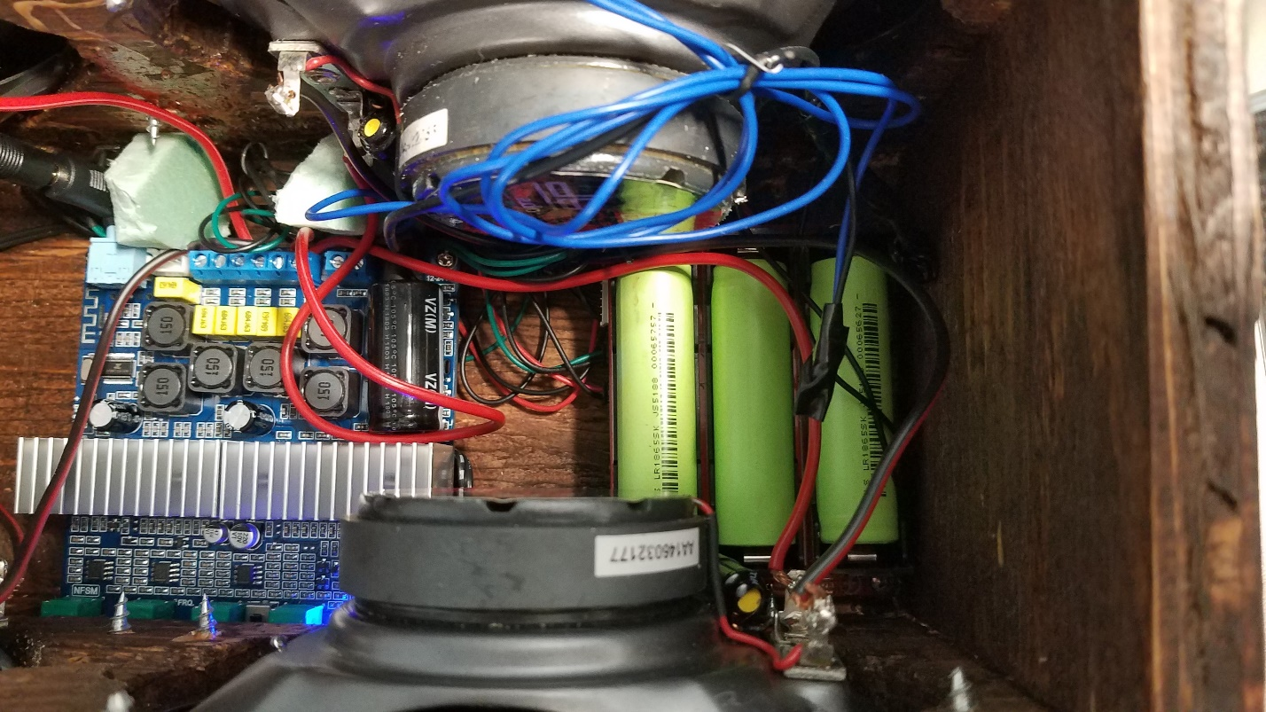

Figure 10: Internal View of Battery